**Task on Ansible-02**

1) Watch ansible-02 video and write down notes.

* Done

2) Install httpd using ansible playbook, use handlers,notifiers  
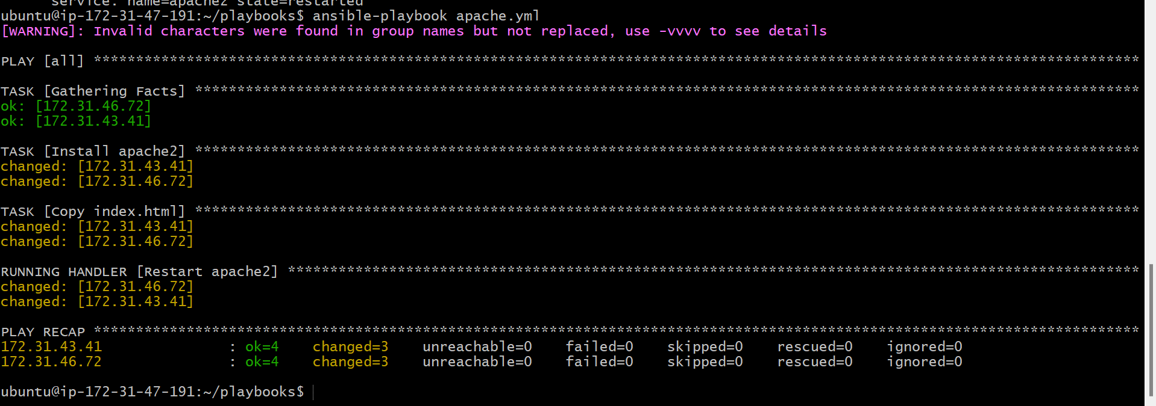

3) Write a ansible playbook to install apache tomcat

4) Write a ansible playbook to provision one ec2 on aws  
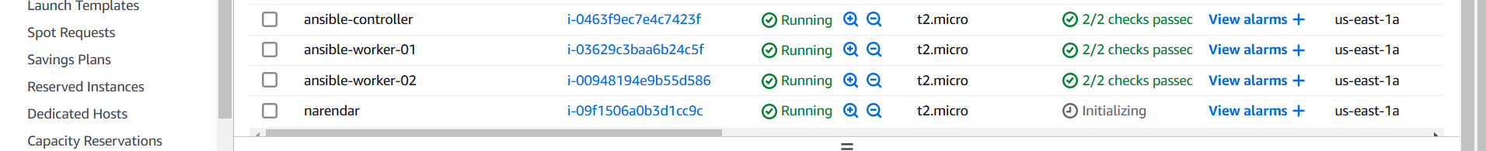  
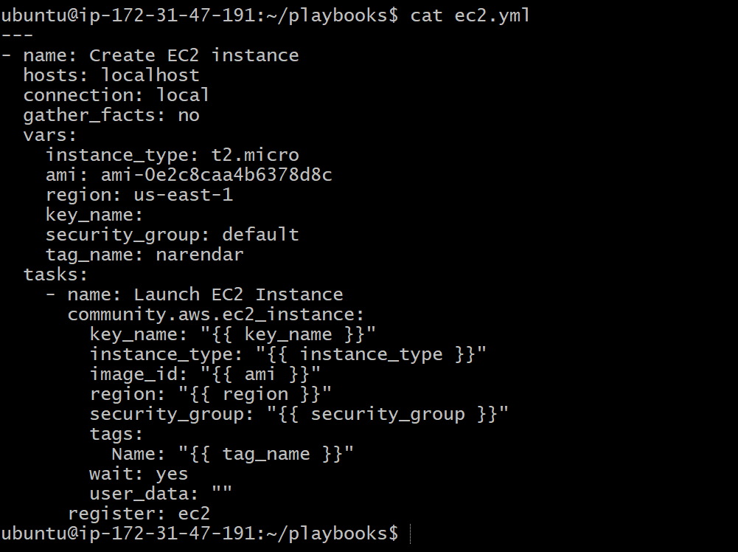

5) Write a ansible playbook to copy one file from node-1 to node-2.

6) Write a ansible playbook to create different files with different names using single playbook  
  
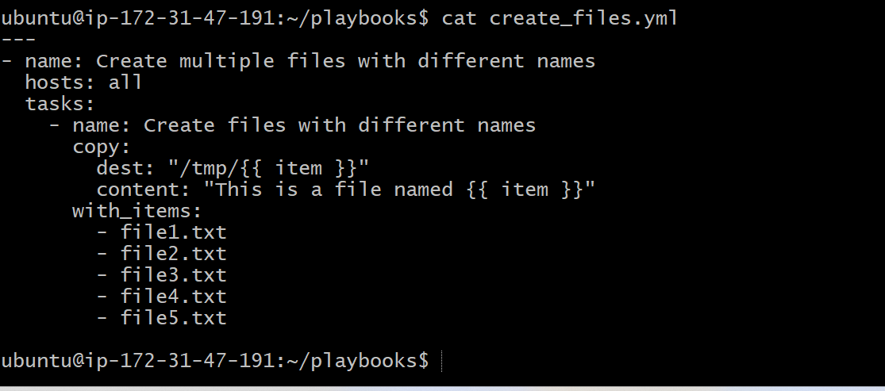  
Worker 01

Worker 02  
worker 02  
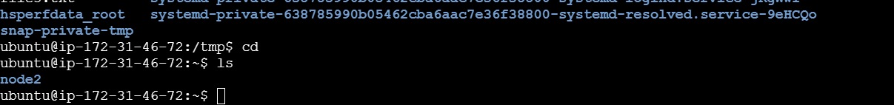  
worker 01  
